Reproducing LoRA: Low-Rank Adaptation for Large Language Models

Brett Warren | Deshaun Jones | Anthony Litwin
CS 722 – Machine Learning
Professor Nazzal
Fall 2025
Old Dominion University

Abstract
Low-Rank Adaptation for Large Language Models (Hu et al., 2021) is an important parameter-efficient fine-tuning (PEFT) method in the solution space for tuning large pre-trained models for multiple downstream tasks. It serves as the foundational PEFT method for more specialized approaches that have extended, modified, or built upon the core ideas introduced by LoRA’s original results. We endeavored to reproduce the experiments of Hu et al. (2021) to confirm the reported findings, deepen our understanding of the methodology, and build practical machine learning engineering skills while applying our theoretical training to a dense research paper and assessing our comprehension. LoRA was originally tested on pre-trained models with up to 175B parameters (GPT-3), which was not feasible given the hardware we had available. From the beginning, our team decided to reproduce only a subset of the original results. We elected to work with RoBERTa-base on the GLUE benchmarks (MNLI and MRPC; Wang et al., 2019) and GPT-2 small and medium models on the E2E NLG Challenge dataset (Novikova et al., 2017). Our results showed that we could generally reproduce the accuracy metrics for natural language inference, paraphrase identification, and the standard E2E NLG scores. We reached 86.8% accuracy on MNLI compared to 87.7% with full fine-tuning, and 88.2% on MRPC compared to 91.2% with full fine-tuning. However, we were far less successful on all GPT-2 evaluations. All supporting code and documentation can be found at: https://github.com/anthonylitwin/odu-cs722-lora-repro/

1 Introduction

1.1 What is LoRA?
Low-Rank Adaptation is a parameter-efficient fine-tuning method that is among the most influential and widely adopted. It has become the modern baseline for PEFT, and many newer methods have been created as extensions of its original findings. The authors’ goal was to create an efficient alternative to full fine-tuning that reduced trainable parameters (and storage) without adding inference latency. Many earlier adapter methods often had trade-offs between efficiency and accuracy. Hu et al. (2021) proposed LoRA, “which freezes the pre-trained model weights and injects trainable rank decomposition matrices into each layer of the Transformer architecture, greatly reducing the number of trainable parameters for downstream tasks.” The main advantage of this approach is that it allows pre-trained models to be shared between tasks while only requiring many small LoRA modules.

1.2 Why does LoRA matter?
Large language models are becoming increasingly expensive to adapt to multiple downstream tasks, as full fine-tuning requires updating and storing all model parameters. Low-Rank Adaptation (LoRA) (Hu et al., 2021) was proposed as a parameter-efficient fine-tuning method to address this challenge. Storage for each downstream task is estimated to be 3–5x larger than the base model when fully fine-tuned. GPT-3 (the largest pre-trained model used in Hu et al., 2021) takes up roughly 350 GB of disk space per checkpoint. This is important because without a PEFT method, “many applications in natural language processing rely on adapting one large-scale, pre-trained language model to multiple downstream applications” (Hu et al., 2021, p. 1). That means large-scale inefficiencies are repeated for every required downstream task.

1.3 Why reproducing LoRA is valuable?
The generic “Why” to reproducing a paper is to help the reader understand practical constraints of the problem. Full fine-tuning seems trivial until you try to produce an accurate model for many different applications. The need for training time, massive storage and large GPU clusters becomes an obvious bottleneck for researchers and students alike. Simply trying to share a model’s checkpoints becomes a point to consider. Furthermore, there are numerous parameters, hyperparameters, and implementation details that could be ambiguous or omitted entirely. Reproduction helps to clarify those challenges and strengthen trust in published methods. LoRA specifically has the bonus of being historically influential and, as previously stated, is the modern baseline for PEFT methods and foundational for future methods. Validating LoRA provided the team with historical insight into how modern solutions leveraged previously successful papers. Case in point, DeBERTa-XXL and GPT-3 experiments were too costly for reproduction thus in this study we focused on RoBERTa-base, GPT-2-small and GPT-2-medium.

2 Background & Problem Statement
Full fine-tuning is expensive. Each parameter of a model is associated with a pre-trained weight, and during full fine-tuning, it is updated to maximize an objective. This must be done for every downstream task. That means all model instances must be stored and deployed with their full complement of parameter values. As of 2021 (the year Microsoft researchers proposed Low-Rank Adaptation), existing methods attempting to tackle this problem (and mentioned by Hu et al.,2021) included bias-only, adapter layers, prefix-layer tuning, and directly optimizing the prompt.
Adapter layers introduced inference latency. These solutions were parameter efficient, had good performance and were modular but had added inference latency. According to Hu et al, “large neural networks rely on hardware parallelism to keep latency low, and adapter layers have to be processed sequentially”. This means “there is no direct way to bypass the extra computer associated with adapter layers” (Hu et al.,2021).
Directly optimizing the prompt is hard. The authors argue that prefix tuning, while parameter-efficient, suffers optimization difficulties and unpredictable performance scaling. Increasing the number of trainable parameters does not consistently improve results, and because prefix vectors consume part of the model’s fixed sequence length, they reduce the available space for downstream inputs. These limitations suggest that prompt-based methods would not be the most fruitful approach.

3 Project Goals
Our team’s reproduction of this paper is important to us for several reasons:
- Confirm Findings: We aim to verify selected results reported by Hu et al. (2021) under our own implementations. Confirming these findings helps assess the veracity of LoRA’s claims across different settings, hardware, and random seeds.
- Deepen our understanding of the methodology: By reimplementing portions of the LoRA pipeline, we gain a clearer understanding of how low-rank adaptation is applied within transformer layers. This process helps us interpret the design choices, assumptions, and constraints underlying the method.

- Build practical machine learning skills: Reproducing the experiments requires hands-on experience with modern model fine-tuning workflows, including dataset preparation, training configuration, evaluation metrics, and debugging. These skills are essential for working with large language models and PEFT techniques.

- Test our knowledge interpreting dense ML research: The LoRA paper contains technical details that require careful reading and reasoning. Attempting to reproduce the work allows us to evaluate our ability to understand, interpret, and translate dense research text into working code.

4 Prior Approaches and Their Limitations

BitFit
Bias only fine-tuning is a baseline method in which only the bias terms in the model are updated while all other parameters remain frozen. This approach greatly reduces the number of trainable parameters. This approach was formally studied in Zaken et al. (2021) who showed that updated bias vectors can help improve performance with natural language processing. It is highly efficient but loses expressive value on more complex tasks.

Adapters
There are four main adapters that the original work focuses its comparisons upon. All contain different trade-offs between performance and efficiency.
Adapter Method | Insert Layer | Design | Limitations
Adapter H (Houlsby et al., 2019) | Between self-attention and after the feed-forward sublayer | Bottleneck adapter modules placed twice per transformer block | Adds significant inference and training overhead
Adapter L (Lin et al., 2020 / Pfeiffer et al.) | After the feed-forward (MLP) layer | Single adapter per transformer block | Underperformance on harder tasks
Adapter P (Parallel Adapter) (Pfeiffer et al., 2021) | Parallel to the MLP sublayer | Adapter runs as a parallel branch; merged with residual output | Introduces inference overhead with performance like Adapter L
Adapter D (AdapterDrop; Rücklé et al., 2021) | Same locations as Adapters L or Adapters H, but selectively dropped | Adapters are removed from certain layers during training or inference | Can reduce accuracy when too many adapters are dropped

Prefix-embedding Tuning
PreEmbed is a parameter-efficient method that utilizes trainable tokens into the input sequence. The exact placement of the tokens within the sequence affects performance. The two types mentioned by Hu et al. (2021) are “prefixing” and “infixing” which both modify the prompt. The detailed explanations of PreEmbed come from Li & Liang (2021).

Prefix-layer tuning
PreLayer is an extension of PreEmbed where prefix and infix tokens are applied at every transformer layer by replacing normal activations with trainable ones. This approach becomes less efficient as the number of parameters grows, is sensitive to token placement, uses more memory, is harder to scale to large models, and increases inference latency because of the extra activations.

5 Proposed Method / Algorithm

Transformers have very large weight matrices and updating every parameter e.g. full fine-tuning becomes increasingly expensive as model size grows. There is evidence from prior studies (Aghajanyan et al.,2020) that although the weight space is large that there exists an intrinsic dimension of useful adaptations that is often much smaller than “full-rank”. LoRA has hypothesized that the weight updated matrix $△W$ can be accurately approximated by a low-rank matrix.
For a pretrained weight matrix $W_{0}∈ R^{d × k}$, LoRA freezes the original pre-trained weights $W_{0}$ and adds low-rank update. Consider the full fine-tuning update formula:
$W^{'}=W_{0}+ ∆W$
$∆W$ represents the full-rank update with no constraints meaning it includes a weight adjustment for all values in the original weight matrix $W_{0}$. In the proposed approach, $∆W=BA$ which represents the decomposition matrix where $B ∈ R^{d × r}$ and $A ∈ R^{r × k}$. The rank, $r ≪min⁡(d, k)$, is the hyperparameter for LoRA rank. Ultimately, parameters are reduced as per the following:
Full-Rank Update: $d ×k$parameters
LoRA Update: $r ×\left(d+k\right)$ parameters
This means that there is often a reduction of parameters of thousands to millions of parameters per layer. The forward pass $h=W_{0}x$is subsequently modified to $h=W_{0}x+ ∆Wx=W_{0}x+ ∆BAx$. The “reparameterization” figure from Hu et al. is featured below:

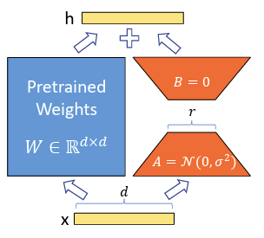
To avoid issues in early steps of training, the authors of LoRA chose to initialize $A$ using a random Gaussian and to set $B$ to zero so that the initial value of $W^{'}=W_{0}$. Thus, $∆W=BA$ begins the update process from zero. $BAx$ scales using $\frac{α}{r}$ where r is the learning rate and $α$ is “LoRA alpha”. This term stabilizes the scaling across changing ranks. In the original LoRA paper, the authors set the LoRA scaling factor $α$ equal to the rank $r$in most experiments, making the effective update scaling $\frac{α}{r}=1$. This results in $α$ and $r$ being numerically identical in practice, which is why they often appear synonymous. A few exceptions (e.g., BERT GLUE experiments) used $α>r$ to increase the updated magnitude.
Hu et al. (2021) found it important to point out two key points:
LoRA is a true generalization of full fine-tuning. It is evidenced by the authors point that “as we increase the number of trainable parameters, training LoRA roughly converges to training the original model” and that “when applying LoRA to all weight matrices and training all biases, we roughly recover the expressiveness of full fine-tuning by setting the LoRA rank $r$ to the rank of the pretrained matrices.”
No additional inference latency is added. They used a simple mathematical demonstration to illustrate a production system. The model can be stored as $W=W_{0}+BA$ which makes recovery of $W_{0}$ as easy as subtracting $BA$ and adding a new $B'A'$ low-rank matrix. This is possible because the rank of $W_{0}$ and $BA$ are both $R^{d × k}$.

5 Experiments and Results

5.1 Summary of the Original Experiments
The original study evaluated multiple transformer model sizes across a range of datasets. For our purposes, we summarized only the configurations as they pertain to the base models in the table below.
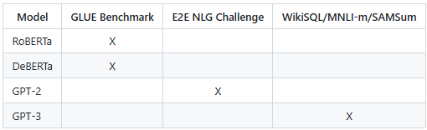
The primary evaluation metrics were GLUE-task accuracy for the classification experiments and standard E2E NLG metrics for the generation tasks. We exclude discussion regarding the experimental setups involving DeBERTa, GPT-3, and their associated datasets, as these configurations were not part of our reproduction.

5.2 Subset Reproduced in Our Study
We limited our scope to model and dataset combinations that were computationally feasible within our available resources. Specifically, we evaluated RoBERTa-base, GPT-2 small, and GPT-2 medium, paired with the MNLI and MRPC tasks from the GLUE Benchmark and the E2E NLG Challenge dataset. Across these settings, we compared three fine-tuning strategies: full fine-tuning, BitFit, and LoRA, including ablation studies over LoRA’s rank and scaling parameter $α$.
Our reproduction covers a focused subset of the results presented in the original LoRA paper, concentrating on downstream tasks and model sizes that allowed for systematic and repeatable experimentation. For RoBERTa-base, we applied LoRA to the sequence-classification heads used in MNLI and MRPC. For each tuning strategy, we collected accuracy, training runtime, evaluation and training loss curves, total parameter counts, and the number of trainable parameters.
For generative modeling, we applied LoRA to GPT-2 small and GPT-2 medium on the E2E NLG Challenge dataset. In addition to the same training and efficiency metrics, we evaluated standard natural language generation scores, including BLEU, METEOR, and ROUGE-L. All GPT-2 experiments likewise included full fine-tuning and BitFit baselines to facilitate direct comparison with LoRA’s performance.

5.3 Implementation and Hyperparameters
A matrix was created for each base-model and dataset combination to compare the LoRA paper’s implementation and hyperparameter choices with those feasible for our reproduction. Access to a V100 GPU on the ODU Wahab Cluster informed several of our decisions. Detailed implementation settings for each shell script are available in our repository at:
https://github.com/anthonylitwin/odu-cs722-lora-repro/tree/main/scripts
There were few things Hu et al. (2021) did not specify, and inventory of those items were taken below:
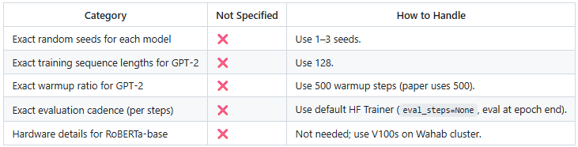

We chose to rely on the original study regarding LoRA’s convergence toward full fine-tuning as $r$approaches full rank, and we restricted our ablation values to {1, 4, 8, 16}.
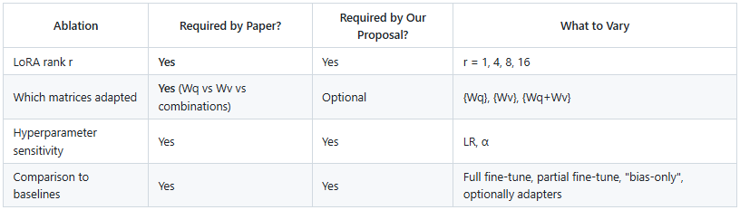

RoBERTa/GLUE Benchmark
The full detailed matrix is provided below, but we want to highlight several intentional decisions we made. All RoBERTa-base (125M parameters) experiment scripts used a single seed, three epochs (due to GPU constraints), a batch size of 16, and a maximum sequence length of 128 to remain consistent with adapter-style baselines and to stay within V100 VRAM limits. We selected MNLI as our primary GLUE Benchmark task, with MRPC used optionally to supplement classification results. Following the original LoRA setup, we applied LoRA only to the query and value projection matrices. While the original paper varied learning rate across tasks, we used a consistent learning rate of 5e-4 for both MNLI and MRPC.
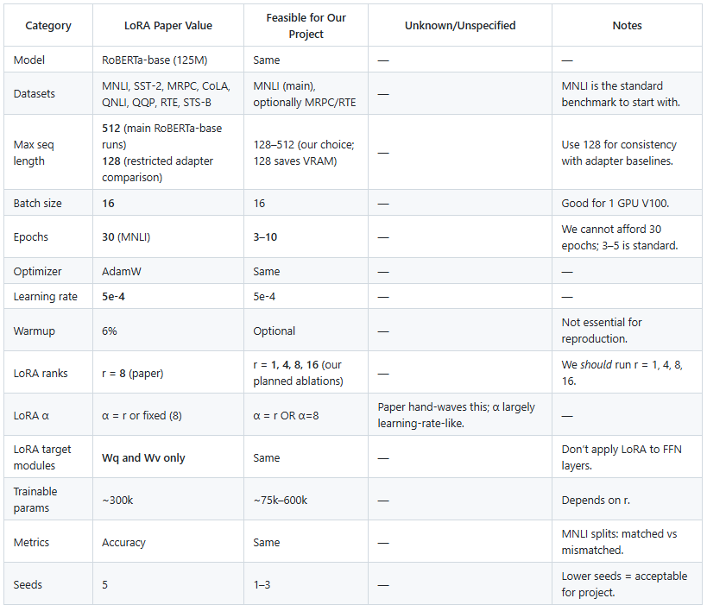

GPT-2/E2E NLG Challenge
For the GPT-2 experiments on the E2E NLG Challenge, we again provide the full configuration matrix below and highlight several intentional decisions here. We ran experiments on both GPT-2 small (124M parameters) and GPT-2 medium (345M parameters) using the E2E NLG dataset, exactly as in the original study. We used a maximum sequence length of 128 tokens because E2E inputs are relatively short – averaging roughly 80 tokens. Batch sizes ranged from 4 to 8 depending on GPU memory constraints, and we trained for 3–5 epochs, aligning closely with the original paper’s five-epoch configuration. We adopted the learning rate of 2e-4 recommended in the LoRA study and used AdamW as the optimizer. LoRA ranks for our ablations were restricted to {1, 4, 8, 16}, while α values ranged from 16 to 32, following the paper’s choice of $α$ = 32 for $r$ = 4 and $α=r$ otherwise. As in the original implementation, LoRA was applied to both the query and value projection modules, but we only employed a single seed.
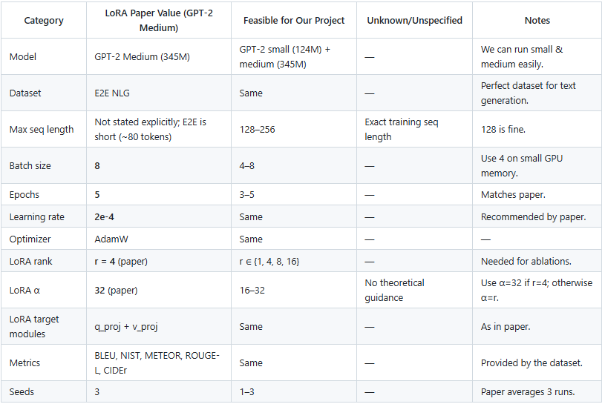

5.4 Evaluation Metrics
Our results for RoBERTa on MNLI and MRPC were loosely correlated with the original study. Even though our models used about eight times more trainable parameters than the original LoRA setup and the accuracy was competitive but still did not beat adapters or the LoRA results from the original paper. However, this comparison does not include inference latency which is where LoRA should best adapter models. And, additionally, our LoRA performance against our own FT and BitFit results were promising.
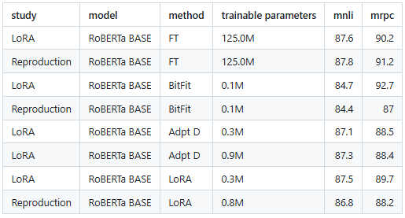
As for for GPT-2 Small and Medium on the E2E NLG Challenge, GPT-2 Large and Medium achieved strong BLEU, ROUGE-L, and METEOR scores while using very few trainable parameters - often under 1M for LoRA and adapter-based methods. In our reproduction, GPT-2 Medium and Small models showed noticeably lower BLEU and ROUGE-L scores, along with higher METEOR scores, suggesting that our models produced more recall-heavy but less precise outputs. Full fine-tuning in our runs required far more trainable parameters but still underperformed the LoRA study's results. Overall, the original LoRA experiments demonstrated clear efficiency and performance benefits, while our reproduction captured the same general trends (within our own experiments) but did not reach the same absolute levels of quality.
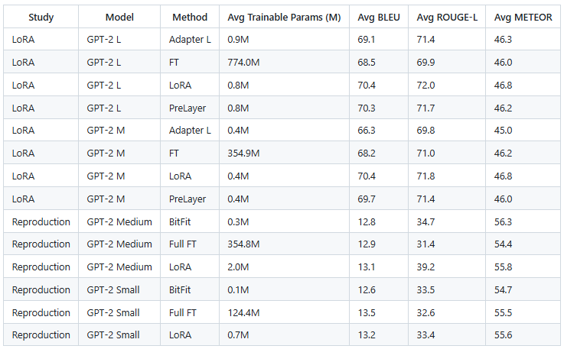

6 Conclusion

Overall, the results we produced showed only a moderate correlation with the performance reported in the original LoRA study. However, the continued reliance on LoRA as a foundational method across both research and industry suggests that the original paper’s claims are sound. LoRA has since inspired a wide family of extensions including QLoRA, DoRA, AdaLoRA, LongLoRA, and LoRA-Drop, which indicates strong confidence in its underlying approach. Because LoRA remains central to many modern fine-tuning pipelines, we believe our reproduction fell short not due to missing or inaccurate information in the original paper, but because of our own constraints and choices. Limited random seeds, fewer training epochs, tighter hardware budgets, and the possibility of misconfigured hyperparameters or implementation bugs likely contributed to weaker results. Meanwhile, industry has moved toward increasingly large models and more sophisticated efficiency strategies, including mixture-of-experts architectures, which selectively activate parameters during inference. These trends reinforce that LoRA continues to play an important role in modern systems, and therefore our reproduction challenges are best attributed to configuration and implementation factors rather than shortcomings in the original work.

7 Discussion

7.1 Impact of Study

Our reproduction highlights for the machine learning community that duplicating published work is not always an entry-level task. Numerous factors influence implementation details - ranging from hardware limits to preprocessing choices to small hyperparameter decisions - so reproduction is rarely a zero-sum exercise. In an educational setting, as in our case, the process serves less as a strict verification and more as a bridge between ML concepts and their practical, system-level realities. As discussed earlier, follow-on research and adoption trends make it clear that LoRA itself became a flagship method that significantly influenced how transformers are fine-tuned efficiently. This broader impact reinforces that the original paper’s claims hold strong, even if our own execution did not fully realize the same performance gains.

7.2 Limitations

Because of limits in both time and compute, we were unable to train using multiple random seeds or running as many epochs. We also could not train the larger model variants or cover all datasets used in the original study. In addition, we did not measure inference latency or reproduce the adapter baselines ourselves; instead, we relied on the original paper’s reported results for those comparisons.

7.3 Future Work
The next most important step is to investigate whether there was a bug in our E2E NLG evaluation pipeline, since our results differed sharply from those reported in the original study. Once that is resolved, we would increase the number of random seeds and run more extensive ablation studies to understand how different variables influenced our outcomes. It would be valuable to explore the interaction between rank and LoRA $α$, examine how learning rate choices shaped performance, and revisit the impact of sequence length on both GLUE and E2E tasks. Another meaningful direction would be to manually construct a small neural network and implement a LoRA module from scratch, without relying on the PEFT library. Doing so could offer deeper insight into how LoRA is injected into transformer layers and how its updates propagate during training. Beyond technical validation, it would also be interesting to experiment with real task-switching scenarios to better visualize the operational benefits that LoRA promises in production environments, especially for organizations managing many downstream tasks on a shared base model.

8 References
-Hu, E. J., Shen, Y., Wallis, P., Allen-Zhu, Z., Li, Y., Wang, S., Wang, L., & Chen, W. (2021). LoRA: Low-Rank Adaptation of Large Language Models. arXiv. https://arXiv.org/abs/2106.09685
-HuggingFace. (2025). PEFT: Parameter-efficient fine-tuning library [Software]. GitHub. https://github.com/huggingface/peft
-GLUE: A multi-task benchmark and analysis platform for natural language understanding. In International Conference on Learning Representations (ICLR). Available at https://gluebenchmark.com/
-Novikova, J., Dušek, O., & Jurčíček, F. (2017). The E2E Dataset: New Challenges for End-to-End Generation. In Proceedings of the 18th Annual SIGdial Meeting on Discourse and Dialogue (pp. 201–206).
-Neil Houlsby, Andrei Giurgiu, Stanislaw Jastrzebski, Bruna Morrone, Quentin de Laroussilhe, Andrea Gesmundo, Mona Attariyan, and Sylvain Gelly. Parameter-Efficient Transfer Learning for NLP. arXiv:1902.00751 [cs, stat], June 2019. URL http://arxiv.org/abs/1902. 00751.
-Zhaojiang Lin, Andrea Madotto, and Pascale Fung. Exploring versatile generative language model via parameter-efficient transfer learning. In Findings of the Association for Computational Linguistics: EMNLP 2020, pp. 441–459, Online, November 2020. Association for Computational Linguistics. doi: 10.18653/v1/2020.findings-emnlp.41. URL https://aclanthology. org/2020.findings-emnlp.41.
-Jonas Pfeiffer, Aishwarya Kamath, Andreas R¨ uckl´ e, Kyunghyun Cho, and Iryna Gurevych. Adapterfusion: Non-destructive task composition for transfer learning, 2021.
-Li, X. L., & Liang, P. (2021). Prefix-Tuning: Optimizing Continuous Prompts for Generation. ACL.
-Andreas R¨ uckl´ e, Gregor Geigle, Max Glockner, Tilman Beck, Jonas Pfeiffer, Nils Reimers, and Iryna Gurevych. Adapterdrop: On the efficiency of adapters in transformers, 2020.
-Aghajanyan, A., Gupta, S., & Zettlemoyer, L. (2020). Intrinsic Dimensionality Explains the Effectiveness of Language Model Fine-Tuning. ACL.
-Wang, A., Singh, A., Michael, J., Hill, F., Levy, O., & Bowman, S. R. (2019). GLUE: A Multi-Task Benchmark and Analysis Platform for Natural Language Understanding. ICLR.
-Dettmers, T., Lewis, M., Shleifer, S., & Zettlemoyer, L. (2023). QLoRA: Quantized Low-Rank Adapters for Efficient Finetuning of Large Models. NeurIPS.
-Ament, S., et al. (2023). DoRA: Weight-Decomposed Low-Rank Adaptation. arXiv.
-Zhang, T., Hu, Y., He, J., Wang, Z., & Xu, Z. (2022). AdaLoRA: Adaptive Low-Rank Adaptation. arXiv.
-LoRA-Drop: Mokady, R., et al. (2023). LoRA Drop: Efficient Adapter Training with Layer Dropping. arXiv.
-Chen, B., et al. (2023). LongLoRA: Efficient Fine-Tuning for Long-Context Transformers. arXiv.
-Shazeer, N., et al. (2017). Outrageously Large Neural Networks: The Sparsely-Gated Mixture-of-Experts Layer. ICLR.
-Brown, T. B., et al. (2020). Language Models are Few-Shot Learners. NeurIPS.

